
Selecting Medical Management of Early Pregnancy Loss

Prior to starting the medication:
- You should feel completely certain that this pregnancy has no chance for survival. We feel confidant and have diagnosed a miscarriage by one of the following;
  - Crown Rump length of 7mm or greater and no heartbeat.
  - Mean sac diameter of 25mm or greater and no embryo.
  - Absence of embryo with heartbeat 2 weeks or more after a scan that showed a gestational sac without a yolk sac.
  - Absence of embryo with heartbeat 11 days or more after a scan that showed a gestational sac with a yolk sac.
- Have at home over the counter ibuprofen (Motrin, Advil) and acetaminophen (Tylenol)
- Received prescriptions
  - Mifeprex (mifepristone): makes Cytotec more effect, blocks progesterone
  - Cytotec (Misoprostol): makes the uterus contract and expel the tissue
  - Oxycodone (or another narcotic): pain medicine for more intense pain
- If using Mifeprex the prescription for Mifeprex and Cytotec need to be sent to a CVS pharmacy. We will decide together which CVS pharmacy you want. CVS will have the medication ready for you on the next business day in the afternoon. If we send the medications on Friday, they will be available on Monday. The pharmacy will hold the medications for only a few days. Plan on picking up the medication as soon as available. If you are having issues, please reach out to our nursing staff.

How to take the medication:
- If taking Mifeprex, you would take the 1 pill by mouth 24 hours prior to starting Cytotec
- On the day of taking Cytotec, place four (4) tablets of 200mcg Cytotec (800mcg total) INTO THE VAGINA as far you can get them and lie flat for 30 minutes.
- Start taking ibuprofen and acetaminophen for pain control. These medications work in different ways and are safe to take to take together. Continue to repeat these medications as you need them
Ibuprofen (Motrin, Advil) 600mg by mouth every 6 hours
Acetaminophen (Tylenol) 1000mg by mouth every 6 hours
- Add the narcotic medication as prescribed if you need additional pain control.
- Expect moderate to heavy bleeding and cramping. You will pass tissue and clots. This typically starts within 6 hours after the medication and will last for about 2 - 4 hours. Every person's body and process is different. Once the uterus is empty, the bleeding and cramping will rapidly taper off and you will feel tired but well.
- If you do not have significant cramping and bleeding a second dose of Cytotec can be taken
Call Alliance or go to the UMH - Sparrow Emergency Room if you experience severe pain, fever greater than 100.4 or symptoms that concern you. Some people will run a low grade fever or have diarrhea and nausea from the medicine and this is okay. If you are having excessive bleeding go directly to the UMH - Sparrow Emergency Room. Excessive bleeding is soaking 1 pad in 30 minutes and this last for 2 hours.
After taking the medication:
Once the miscarriage has passed, we will repeat an ultrasound to make sure the uterus is empty. After the ultrasound we will start weekly blood draws to follow the beta HCG pregnancy hormone down to less than 5. Bleeding may last up to 10 days, but should not be heavy or painful. Expect your first period to begin 3 - 6 weeks after the medication. Once the miscarriage has passed, it is okay to start trying immediately for pregnancy or we can start you on birth control.

Updated EJT 7/2026

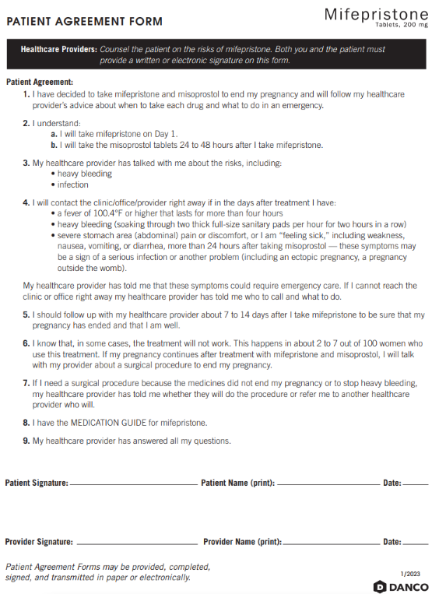
Place Patient Barcode Here
Scan into Athena ONLY

